**EXPERIMENT 6**

**AIM: Working with Docker Compose File to Control Multiple Containers**

Steps to Complete:

Creating compose files ❖ Create a directory named **nginx in your root**

* **mkdir nginx**

Switch to that directory and create a file named docker-compose.yaml cd nginx vi docker-compose.yml

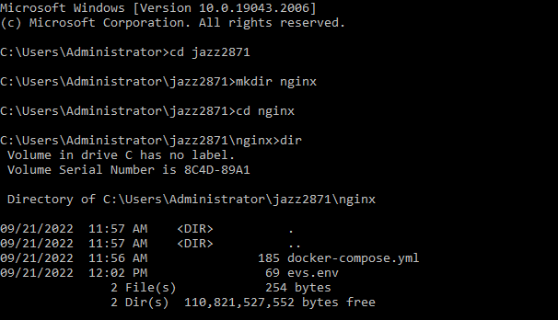

❖ Use docker-compose version 2 to create docker-compose.yaml file. Create a service named "databases". Use image named "mysql" Map container 3306 port to host machine 3306 port.

* Add environment variables named "MYSQL_ROOT_PASSWORD", "MYSQL_DATABASE", "MYSQL_USER" and "MYSQL_PASSWORD" along with corresponding values for all.

cat evs.env MYSQL_ROOT_PASSWORD=redhat08 MYSQL_DATABASE=nginxdb MYSQL_USER=root

* Add another service named "web" Use image "nginx" cat docker-compose.yml version: '3' services: databases: image: mysql ports: - "3307:3306" env_file: - evs.env web: image: nginx ports: - "80:80" depends_on: - databases.

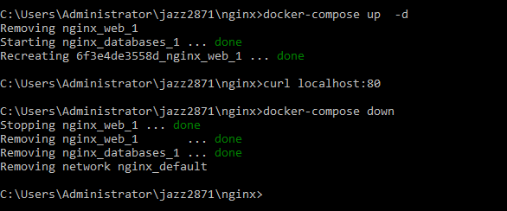

* Running images using docker-compose
* Save docker-compose.yaml file and do docker-compose up. docker-compose up -d .Verify nginx service is up and is accessible on machine. curl localhost:80 Stop and remove your docker container using docker-compose. docker-compose down.

